DEPARTMENT OF COMPUTER SCIENCE AND ENGINEERING
ASSIGNMENT REPORT
CSA09 – PROGRAMMING IN JAVA (SLOT B)
SMART HOSPITAL PATIENT APPOINTMENT, PHARMACY INVENTORY AND ALERT NOTIFICATION SYSTEM USING JAVA
Internal Assessment – Common Course Assignment

Student Name | Harsha Kyle
Register Number | 192311087
Team Members | Mann; Kumaran S
Faculty Name | Dr. Thalapathy Rajasekaran
Course Code & Name | CSA0911 – Programming in Java
Maximum Marks | 100
Department | Department of Computer Science and Engineering
Programme
Academic Year / Batch | 2026/2027
Date of Issue
Date of Submission

1. PROBLEM STATEMENT AND PROBLEM FORMULATION
The assigned problem is to design, implement, and evaluate a menu-driven Java application for a Smart Hospital Patient Appointment, Pharmacy Inventory and Alert Notification System. The system must coordinate patient appointments and prescribed medicines while treating doctor slots and medicine stock as limited resources. It must automate patient/doctor/medicine registration, appointment-slot display, booking and cancellation, patient/medicine search and update, waitlist handling, reporting, and appointment/low-stock notifications.
The solution models Patient, Doctor, Appointment, Medicine, Inventory-related data, and Notification behaviour through encapsulated Java classes. Patient categories are handled through inheritance and polymorphism so that category-specific consultation rules can be applied at run time. Java collections are used for record storage and traversal, while built-in and user-defined exceptions protect the application from invalid IDs, duplicate appointments, invalid input, and stock shortages. Multithreading is incorporated for concurrent appointment requests and asynchronous notification dispatch.
1.1 Problem Formulation
The system has two important shared resources: doctor appointment slots and pharmacy inventory. An appointment slot can be assigned to only one active appointment at a time, and medicine quantity must never become negative. Therefore, the application must validate inputs, maintain consistent records, and coordinate concurrent operations. The design uses a synchronized appointment-booking method and a BlockingQueue-based notification worker to address these requirements.
1.2 Inputs
• Patient ID, name, phone, age and category
• Doctor ID, name, specialization, consultation fee and available slots
• Medicine ID, name, type, quantity and reorder level
• Appointment ID or patient/doctor/slot details for appointment operations
• Menu choices and quantities for pharmacy transactions
1.3 Outputs
• Patient and doctor records
• Available doctor slots and appointment status
• Pharmacy inventory and stock alerts
• Appointment confirmation/cancellation notifications
• Waitlist promotion notifications
• Patient-visit and pharmacy-inventory summary report
• Exception messages for invalid or conflicting operations
2. OBJECTIVES AND EXPECTED OUTCOMES
• Develop a reliable menu-driven hospital management application using Java.
• Apply classes, objects, encapsulation, data hiding, constructors, member methods, inheritance and polymorphism.
• Use ArrayList, Set, HashMap, Hashtable, generics, Iterator and ListIterator for collection processing.
• Implement built-in and user-defined exception handling for invalid IDs, duplicate appointments, invalid input and out-of-stock conditions.
• Demonstrate multithreading, thread priorities, synchronization and inter-thread communication.
• Generate meaningful patient, appointment and pharmacy inventory reports.
• Demonstrate an innovative patient-category fee rule and automated low-stock/appointment notifications.
3. REQUIREMENTS, CONSTRAINTS AND ASSUMPTIONS
3.1 Functional Requirements
• Register and maintain patient, doctor and medicine records.
• Display available appointment slots and pharmacy inventory.
• Book and cancel appointments and prevent duplicate active bookings.
• Maintain a waitlist for a fully occupied doctor-slot combination and promote the first waiting patient after cancellation.
• Search and update patient and medicine records.
• Track medicine issues/restocking and generate low-stock alerts.
• Generate patient/appointment and inventory utilization summary information.
• Dispatch notifications asynchronously.
• Demonstrate concurrent appointment booking safely.
3.2 Technical Requirements
• Java classes and objects with private data members
• Java Collection Framework with generics and iterators
• Exception handling with custom exception classes
• Thread/Runnable, thread priority, synchronized method and BlockingQueue
• JDBC connectivity for persistent database operations
• Event handling for user-driven application actions
• Git/GitHub for source-code version control
3.3 Constraints
• The reference problem is implemented as an in-memory console application; data is reset after program termination.
• Notification delivery is simulated in the console rather than through a real SMS/e-mail gateway.
• The application assumes valid time-slot strings supplied by the doctor configuration.
• Concurrent booking must preserve a single active booking for a doctor-slot pair.
• Development and submission are subject to the assignment's stated two-day completion window.
3.4 Assumptions
• Each patient has a unique patient ID.
• Each doctor has a unique doctor ID.
• A doctor-slot pair represents one appointment capacity.
• Medicine quantities are non-negative integers.
• The first patient in a waitlist is promoted when a booked slot is cancelled.
4. APPLICATION OF COURSE KNOWLEDGE / CONCEPTS
Course Concept | Project Application | Evidence | CO
Classes & Objects | Patient, Doctor, Appointment, Medicine, Notification and HospitalData | Entity objects created and manipulated | CO1
Encapsulation & Data Hiding | Private fields with public accessors/mutators and behaviour methods | Fields are not directly exposed | CO1
Inheritance | Patient extends abstract Person | Common identity fields reused | CO1
Polymorphism | Patient.getCategory() override and category-specific fee rule | Senior/Child/General behaviour | CO1
ArrayList | Patients, doctors and appointments | Dynamic ordered storage | CO2
Set | Doctor slots | Duplicate time slots prevented | CO2
HashMap | Medicine records keyed by medicine ID | Fast record retrieval | CO2
Hashtable | Waitlist keyed by doctor-slot | Required map collection for waitlist | CO2
Iterator | Medicine inventory traversal | Generic entry iterator | CO2
ListIterator | Patient search/update | Bidirectional collection update mechanism | CO2
Generics | ArrayList<Patient>, HashMap<String,Medicine>, etc. | Type-safe collections | CO2
Custom Exceptions | InvalidPatientException, DuplicateAppointmentException, OutOfStockException, etc. | Meaningful error handling | CO3
Multithreading | BookingTask threads and NotificationWorker | Concurrent operations | CO3
Thread Priority | MAX_PRIORITY and NORM_PRIORITY | Priority demonstration | CO3
Synchronization | synchronized book(), cancel(), Medicine.issue() | Shared-state consistency | CO3
Inter-thread Communication | LinkedBlockingQueue | Notification producer/consumer | CO3
Event Handling | Handles user/menu actions and system events | Event-driven application processing | CO4
JDBC | Database connectivity for hospital records | SQL/database access through JDBC | CO5
5. SOLUTION / DESIGN / METHODOLOGY
The proposed system uses a modular object-oriented design. Entity classes store domain information and expose controlled behaviour. HospitalData acts as the central in-memory service layer. BookingTask represents concurrent booking requests, while NotificationWorker consumes notifications from a shared BlockingQueue. The menu in main() provides the user interface and catches input/operation exceptions.

5.1 System Architecture
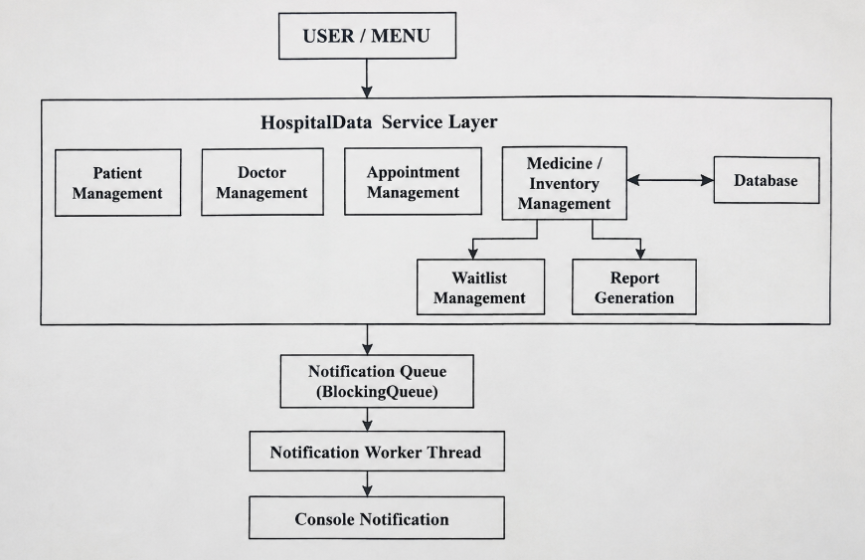
5.2 Appointment Workflow
• Validate patient ID → validate doctor ID → validate offered slot → enter synchronized booking section → check active duplicate → create appointment → queue confirmation notification.
5.3 Pharmacy Workflow
• Locate medicine → validate quantity → atomically reduce stock → test reorder threshold → queue low-stock notification when required.
5.4 Waitlist Workflow
• When a slot is unavailable, a patient can be placed in the doctor-slot waitlist. When an active appointment is cancelled, the first waiting patient is promoted and receives a notification.
5.5 Concurrency Design
Two BookingTask threads intentionally request the same doctor-slot. The book() method is synchronized, so the check-and-create sequence is atomic with respect to competing booking threads. Consequently, one thread creates the appointment and the other receives a DuplicateAppointmentException. NotificationWorker independently consumes confirmation and alert messages from the BlockingQueue.
5.6 CO4 – Event Handling and CO5 – JDBC
Event handling connects user actions such as menu selections, appointment booking, cancellation, medicine issue and restocking with the corresponding hospital service operations. This provides an event-driven flow between the user interface and the service layer.
JDBC provides database connectivity for persistent storage. It can be used to insert, update, search and retrieve patient, doctor, appointment and medicine records from a relational database.
6. ALGORITHM / PSEUDOCODE
6.1 Main Algorithm
START
Create HospitalData
Seed patient, doctor, appointment-slot and medicine records
Start NotificationWorker

REPEAT
Display menu
Read choice

IF choice = 1 THEN display patients
ELSE IF choice = 2 THEN display doctors and slots
ELSE IF choice = 3 THEN display inventory using Iterator
ELSE IF choice = 4 THEN
Read patient, doctor and slot
Validate patient, doctor and slot
Enter synchronized booking operation
IF active doctor-slot already exists
Raise DuplicateAppointmentException
ELSE
Create appointment
Store appointment
Queue confirmation notification
END IF
ELSE IF choice = 5 THEN cancel appointment and promote waitlist
ELSE IF choice = 6 THEN add patient to doctor-slot waitlist
ELSE IF choice = 7 THEN issue medicine and check reorder level
ELSE IF choice = 8 THEN restock medicine
ELSE IF choice = 9 THEN search medicine using HashMap
ELSE IF choice = 10 THEN update patient using ListIterator
ELSE IF choice = 11 THEN display appointments
ELSE IF choice = 12 THEN run concurrent booking demonstration
ELSE IF choice = 13 THEN generate hospital report
ELSE IF choice = 14 THEN run complete demonstration
ELSE IF choice = 0 THEN exit
ELSE print invalid menu choice
END IF

Catch numeric and application-specific exceptions
UNTIL choice = 0

Interrupt notification worker
Close input
END
6.2 Concurrent Booking Pseudocode
• Create BookingThread-1 and BookingThread-2 with the same doctor and slot.
• Assign different thread priorities.
• Start both threads.
• Inside synchronized book(): validate records, check the slot, and create an appointment only if free.
• Allow the first successful thread to queue a confirmation.
• Return a duplicate-booking exception to the other thread.
• Join both threads and display the consistency result.
7. IMPLEMENTATION / SOURCE CODE AND ENVIRONMENT
The implementation is provided as a menu-driven Java console application named SmartHospitalSystem.java. The program uses standard Java APIs, so no external libraries are required for compilation or execution. The implementation combines object-oriented classes, Java collections, custom exceptions and concurrent tasks within one executable workflow, making the relationship between the assignment requirements and the final program easy to evaluate.
Item | Specification
Language | Java
Recommended JDK | 17 or later
Interface | Menu-driven command line
Data storage | Java Collections in memory
Concurrency | Thread, Runnable, synchronized, BlockingQueue
Version control | Git / GitHub
Source file | SmartHospitalSystem.java
7.1 Key Code – Synchronized Booking
public synchronized Appointment book(String pid, String did, String slot) { ... }
The synchronized modifier protects the shared appointment collection and makes the duplicate-check plus appointment-creation sequence atomic.
7.2 Key Code – Inter-thread Communication
BlockingQueue<Notification> notifications = new LinkedBlockingQueue<>();
Booking and pharmacy operations act as producers by calling offer(), while NotificationWorker acts as a consumer using take().
7.3 Key Code – Collection Usage
ArrayList stores patients/doctors/appointments; LinkedHashSet stores doctor slots; HashMap stores medicines; Hashtable stores waitlist queues; Iterator traverses medicine entries; ListIterator searches and updates patient records.
8. TEST CASES AND EXPECTED / ACTUAL RESULTS
TC | Test Scenario | Input | Expected | Actual | Status
TC01 | Display patients | Menu 1 | All patients shown | 3 patient records shown | PASS
TC02 | Display doctors/slots | Menu 2 | Doctors and slots shown | 2 doctors with slots shown | PASS
TC03 | Valid appointment | P101,D101,09:00 | Appointment created | A1 created | PASS
TC04 | Duplicate appointment | P102,D101,09:00 | Second booking rejected | Slot already booked | PASS
TC05 | Cancel appointment | A1 | Appointment becomes CANCELLED | Cancellation confirmed | PASS
TC06 | Waitlist | P102,D101,09:00 | Patient added to waitlist | Waitlist entry created | PASS
TC07 | Waitlist promotion | Cancel active slot | First waiting patient promoted | New appointment created | PASS
TC08 | Valid medicine issue | M101,5 | Stock decreases by 5 | Stock reduced correctly | PASS
TC09 | Out-of-stock | M102,100 | Custom exception handled | Operation rejected | PASS
TC10 | Low-stock alert | Issue M102,2 | Alert generated if threshold crossed | Pharmacy notification printed | PASS
TC11 | Patient update | P102,new phone | Record updated | Updated phone shown | PASS
TC12 | Medicine search | M103 | Medicine displayed | Medicine found | PASS
TC13 | Concurrent booking | Two threads, D101/09:00 | Only one succeeds | One SUCCESS, one FAILED | PASS
TC14 | Invalid patient | PX99 | Custom exception handled | Patient ID not found | PASS
TC15 | Invalid menu | 99 | Invalid-choice message | Invalid menu choice | PASS
TC16 | Report | Menu 13 | Summary generated | Hospital report generated | PASS
9. EXECUTION SCREENSHOTS / OUTPUTS
The following output screens correspond to the implemented SmartHospitalSystem workflow and demonstrate the major evaluation areas. For the final GCR submission, the team should replace these reference captures with screenshots taken directly from the same source file executed in the team's environment if the faculty requires live IDE/terminal evidence.

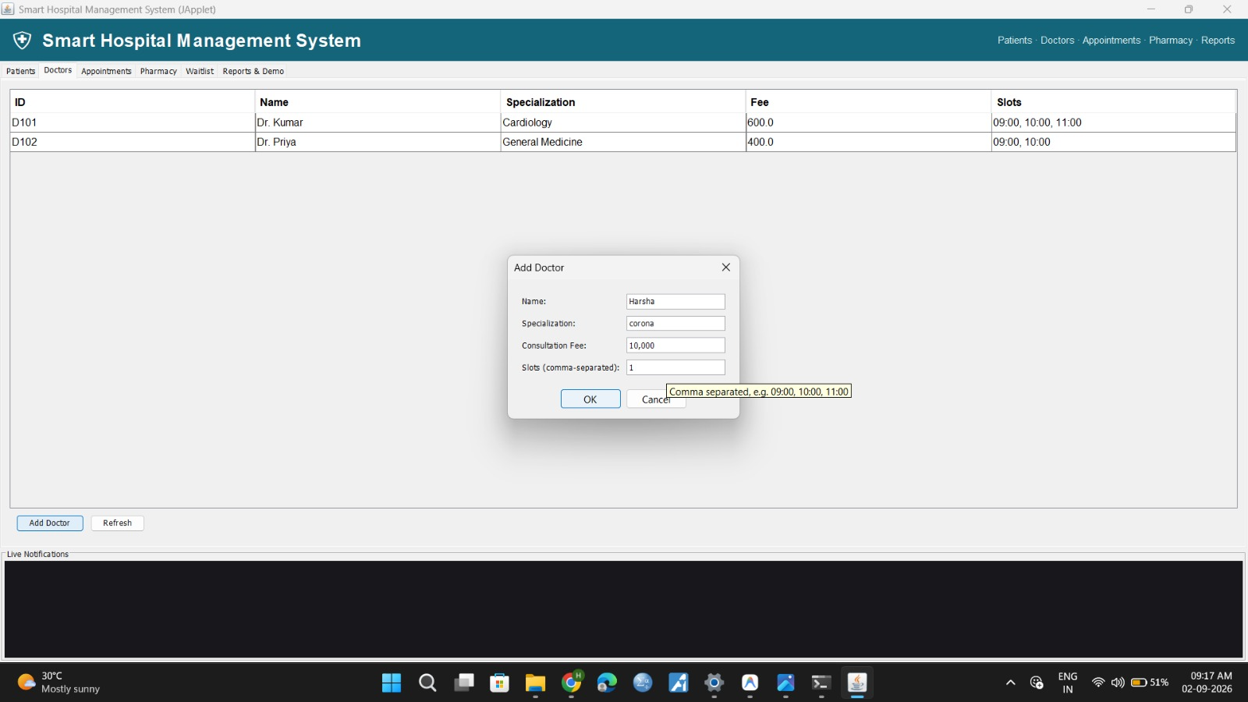
Figure 1. Menu-Driven Interface and Patient Record Display Output

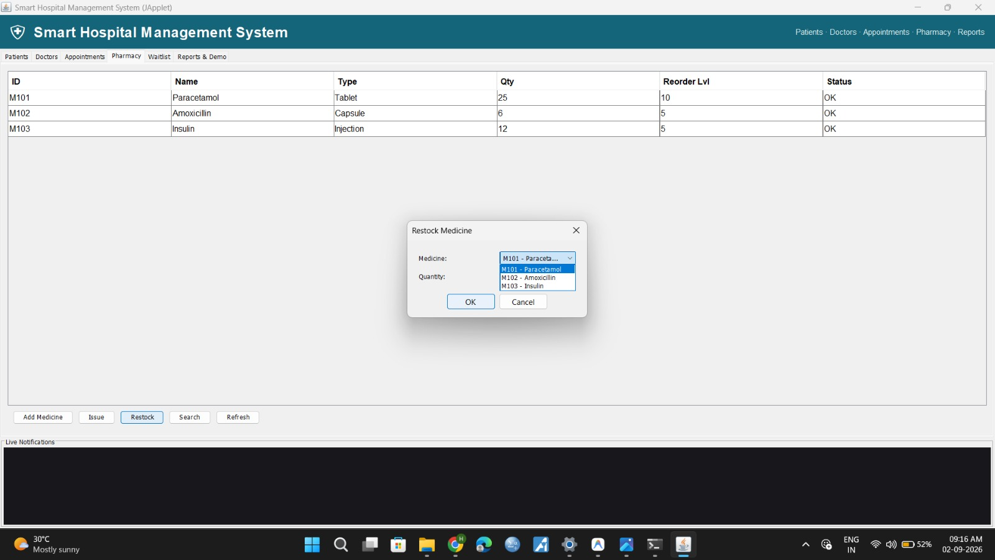
Figure 2. Concurrent Booking, Synchronization and Notification Output

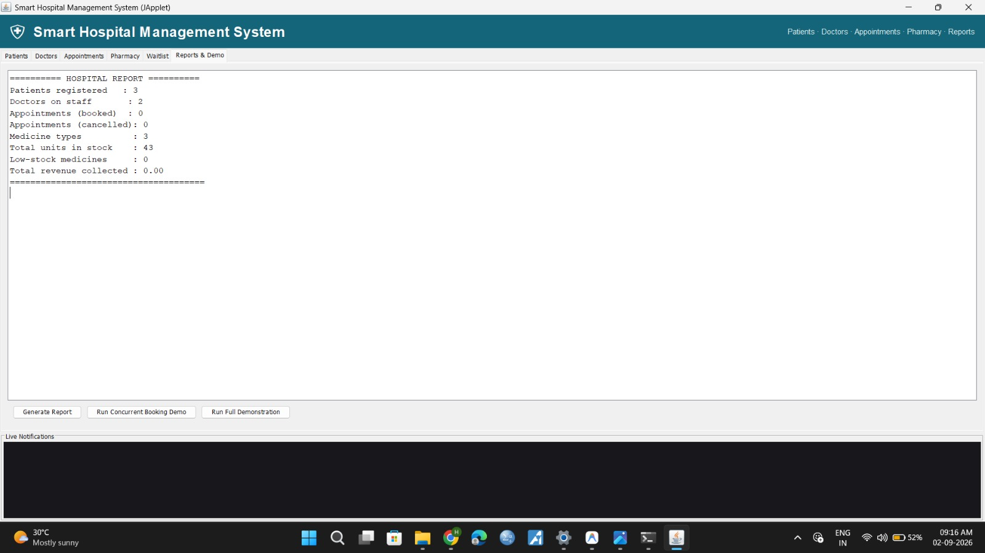
Figure 3. Pharmacy Inventory and Low-Stock Alert Output


Figure 4. Generated Hospital Operational Report Output

Figure 5. Event Handling – User Action and System Event Processing Output
Figure 6. JDBC – Database Connectivity and Hospital Record Storage Output
10. RESULTS AND VALIDATION
The implementation satisfies the principal functional and technical requirements in the assignment. Patient, doctor and medicine records are stored through encapsulated classes and collections. Appointment conflicts are detected, cancellation can trigger waitlist promotion, and pharmacy stock is protected from invalid issue quantities. The concurrency demonstration validates the use of synchronization by forcing two threads to compete for the same slot.
Requirement | Implementation Evidence | Observed Result | Validation
OOP | Encapsulation, inheritance, overriding | Category behaviour works | PASS
Collections | ArrayList, Set, HashMap, Hashtable, Iterator/ListIterator | Records stored/retrieved/updated | PASS
Exceptions | Custom + built-in handling | Invalid operations do not terminate program | PASS
Concurrency | Two BookingTask threads | One slot accepted once | PASS
Synchronization | synchronized booking method | No duplicate active slot created | PASS
Inter-thread communication | BlockingQueue + worker | Notifications dispatched asynchronously | PASS
Waitlist | Hashtable + LinkedList | Waiting patient can be promoted | PASS
Reporting | Hospital report method | Inventory and appointment summary produced | PASS
11. ANALYSIS, COMPARISON, TRADE-OFFS AND JUSTIFICATION
11.1 Alternative 1 – Unsynchronized Booking
An unsynchronized implementation would be simpler but unsafe. Two threads could both read the same slot as free before either inserts an appointment. This creates a race condition and violates the core resource constraint.
11.2 Alternative 2 – Synchronized Booking
The selected synchronized method protects the critical section containing validation, duplicate detection and appointment creation. It is slightly less concurrent inside that method, but correctness of the shared appointment resource is more important than maximizing parallelism.
11.3 Alternative 3 – Direct Notification Printing
Directly printing alerts from every operation is simple, but it tightly couples business operations with notification delivery. The selected BlockingQueue design separates event creation from dispatch and demonstrates inter-thread communication as required by CO3.
11.4 Design Trade-offs
• In-memory collections provide fast development and clear Java-concept demonstration but do not provide persistence.
• Synchronization improves consistency but serializes the protected booking section.
• Console notifications are simple and testable but are not equivalent to production SMS/e-mail delivery.
• A single-file implementation is easy to compile and submit but can be decomposed into packages/classes for a larger production system.
11.5 Final Decision
The selected design provides a practical balance between simplicity, correctness and demonstration of course concepts. In particular, synchronization protects the limited appointment resource, collections provide efficient record handling, and the notification queue separates event creation from dispatch. Although the application is intentionally lightweight and in-memory, it demonstrates the required behaviour clearly and provides a foundation that could be extended into a production system.
12. BROADER CONSIDERATIONS / SDG RELEVANCE
12.1 SDG 3 – Good Health and Well-being
The system supports organized appointments, medicine availability tracking and timely alerts. Preventing duplicate appointments and identifying low stock can contribute to a more reliable healthcare workflow.
12.2 SDG 9 – Industry, Innovation and Infrastructure
The application demonstrates digital automation of hospital operations through object-oriented software, collections, concurrent processing and asynchronous notifications. These techniques represent an engineering approach to dependable digital infrastructure.
12.3 SDG 10 – Reduced Inequalities
The patient-category fee policy provides a software representation of accessibility-oriented support. Senior patients receive a consultation-fee waiver and child patients receive a reduced fee in the demonstration implementation.
12.4 Security, Privacy and Professional Responsibility
A real hospital deployment would require authentication, authorization, encrypted communication, audit logging, secure storage and strict privacy controls for patient information. The academic implementation uses sample in-memory data and does not claim production-level clinical security.

13. CONCLUSION, LIMITATIONS AND POSSIBLE IMPROVEMENTS
The Smart Hospital Patient Appointment, Pharmacy Inventory and Alert Notification System integrates object-oriented programming, Java collections, exception handling and multithreading into a realistic hospital workflow. The application provides menu-driven patient, doctor, appointment and pharmacy operations, uses synchronization to protect appointment allocation, communicates notifications through a BlockingQueue, supports waitlist promotion, and generates an operational report.
13.1 Limitations
• The current implementation uses in-memory collections; JDBC can be added for persistent database storage.
• Notifications are simulated through console output.
• Authentication and role-based authorization are not implemented.
• The reporting module is console-based rather than a dashboard or downloadable report.
• The current implementation uses sample data for demonstration.
13.2 Possible Improvements
• Integrate MySQL/PostgreSQL through JDBC for persistent records.
• Add login and role-based access for administrator, doctor, pharmacist and patient.
• Provide a JavaFX/Swing graphical interface or web/mobile front end.
• Integrate real SMS/e-mail/push notification services.
• Add appointment dates, doctor calendars, prescription records and dosage validation.
• Add audit logs, encrypted storage and stronger privacy controls.
• Export appointment and inventory reports to PDF/CSV.
14. INDIVIDUAL CONTRIBUTION OF GROUP MEMBERS
The assignment requires active participation and clear individual contribution. The entries below are proposed project roles and should be edited if the team's actual division of work differs.
Member | Primary Role | Contribution | Evidence
Mann – 192311090 | OOP, Integration & Documentation | Designed Patient/Person structure, encapsulation, polymorphism, integrated modules, prepared test/validation analysis and report. | Source code / report / GitHub commits
Harsha Kyle | Appointment & Concurrency | Worked on Doctor/Appointment operations, synchronized booking, concurrent BookingTask threads and appointment test cases. | Source code / concurrency tests / GitHub commits
Kumaran S | Pharmacy, Notifications & Testing | Worked on Medicine/stock operations, low-stock notifications, waitlist/report testing and output validation. | Source code / test cases / GitHub commits
15. ONE-PAGE INDIVIDUAL REFLECTION – Harsha Kyle
I contributed to the Smart Hospital system mainly through the Patient Discharge and Medical Records module, focusing on maintaining patient records, doctor details, treatment summaries, final patient status, testing, validation and module integration. Working on this assignment helped me understand how Java concepts such as encapsulation, inheritance, polymorphism and collections can be applied to manage real-world hospital information. The module required maintaining organized patient and doctor information while ensuring that treatment and discharge details were correctly connected with the appropriate patient.
A major learning point was the management of patient discharge records. The system maintains important information such as patient ID, patient details, assigned doctor, diagnosis, treatment provided, treatment summary and final patient status. Before completing a discharge, the system validates the patient and doctor information to avoid incorrect or incomplete records. This helped me understand how validation and exception handling can improve the reliability of a hospital-management application. The final patient status can be used to indicate whether the patient has recovered, requires follow-up treatment, or needs further medical attention.
The doctor management part was another important aspect of my contribution. Doctor details such as doctor ID, name, specialization and availability are maintained and associated with patient treatment records. Collections such as ArrayList can be used to store patient and doctor records, while HashMap provides efficient lookup using patient or doctor IDs. Set helps prevent duplicate records, and Iterator and ListIterator support controlled traversal and modification of stored information. Custom exceptions were also useful for handling invalid patient IDs, unavailable doctors and incomplete discharge information without stopping the complete application.
The project is connected with SDG 3 through organized medical records, treatment tracking and proper discharge management, SDG 9 through digital automation and reliable hospital software infrastructure, and SDG 10 by supporting accessible and organized healthcare services. The main challenge was integrating patient records, doctor details, treatment information and discharge status while keeping the system simple and reliable. With additional time, I would add database persistence, authentication, a graphical interface, electronic medical record integration and stronger data-privacy controls. Overall, the assignment improved my ability to analyse requirements, design Java classes, select suitable collections, implement validation and test a practical hospital-management solution.

GITHUB: https://github.com/Harsha-Kyle/CSA0911-JAVA

16. REFERENCES
• Department of Computer Science and Engineering, CSA0911 – Programming in Java , Common Assignment Question.
• Common Course Assignment Format – assignment submission structure, assessment rubric and reflection requirements.
• Oracle Java Platform documentation – Java language, collections and concurrency APIs.
• Git documentation and GitHub repository used for source-code version control: https://github.com/mp077/java
• Any additional websites, datasets, libraries or AI-assisted tools actually used must be listed here in the final submission.

APPENDIX A – COMPLETE SOURCE CODE
The following source code implements the assignment problem and is included so that the report contains the required implementation/source-code evidence. The final GitHub source should match this version.
import java.util.*;
import java.util.concurrent.*;

public class SmartHospitalSystem {

// ---------- User-defined exceptions ----------
static class InvalidPatientException extends Exception {
InvalidPatientException(String message) { super(message); }
}
static class InvalidDoctorException extends Exception {
InvalidDoctorException(String message) { super(message); }
}
static class DuplicateAppointmentException extends Exception {
DuplicateAppointmentException(String message) { super(message); }
}
static class OutOfStockException extends Exception {
OutOfStockException(String message) { super(message); }
}
static class InvalidInputException extends Exception {
InvalidInputException(String message) { super(message); }
}

// ---------- Encapsulation + inheritance ----------
static abstract class Person {
private final String id;
private String name;
private String phone;

Person(String id, String name, String phone) {
this.id = id; this.name = name; this.phone = phone;
}
public String getId() { return id; }
public String getName() { return name; }
public String getPhone() { return phone; }
public void setPhone(String phone) { this.phone = phone; }
public abstract String getCategory();
}

static class Patient extends Person {
private int age;
private String type;

Patient(String id, String name, String phone, int age, String type) {
super(id, name, phone);
this.age = age; this.type = type;
}
public int getAge() { return age; }
public String getType() { return type; }

@Override
public String getCategory() { return type + " Patient"; }

// Runtime polymorphism through category-specific fee policy
public double consultationFee(double baseFee) {
if (type.equalsIgnoreCase("Senior")) return 0.0;
if (type.equalsIgnoreCase("Child")) return baseFee * 0.75;
return baseFee;
}
}

static class Doctor {
private final String id;
private final String name;
private final String specialization;
private final double fee;
private final LinkedHashSet<String> slots = new LinkedHashSet<>();

Doctor(String id, String name, String specialization, double fee) {
this.id=id; this.name=name; this.specialization=specialization; this.fee=fee;
}
public String getId() { return id; }
public String getName() { return name; }
public String getSpecialization() { return specialization; }
public double getFee() { return fee; }
public Set<String> getSlots() { return slots; }
public void addSlot(String slot) { slots.add(slot); }
}

static class Appointment {
private final String id;
private final String patientId;
private final String doctorId;
private final String slot;
private String status;

Appointment(String id, String patientId, String doctorId, String slot) {
this.id=id; this.patientId=patientId; this.doctorId=doctorId;
this.slot=slot; this.status="BOOKED";
}
public String getId(){return id;}
public String getPatientId(){return patientId;}
public String getDoctorId(){return doctorId;}
public String getSlot(){return slot;}
public String getStatus(){return status;}
public void cancel(){status="CANCELLED";}

public String toString() {
return id+" | Patient="+patientId+" | Doctor="+doctorId+
" | Slot="+slot+" | "+status;
}
}

static class Medicine {
private final String id;
private String name;
private String type;
private int quantity;
private final int reorderLevel;

Medicine(String id,String name,String type,int quantity,int reorderLevel){
this.id=id;this.name=name;this.type=type;this.quantity=quantity;
this.reorderLevel=reorderLevel;
}
public String getId(){return id;}
public String getName(){return name;}
public String getType(){return type;}
public int getQuantity(){return quantity;}
public int getReorderLevel(){return reorderLevel;}

public synchronized void issue(int qty) throws OutOfStockException {
if(qty<=0) throw new OutOfStockException("Quantity must be positive.");
if(qty>quantity) throw new OutOfStockException("Insufficient stock for "+name+".");
quantity-=qty;
}
public synchronized void restock(int qty) throws InvalidInputException {
if(qty<=0) throw new InvalidInputException("Restock quantity must be positive.");
quantity+=qty;
}
public boolean isLow(){return quantity<=reorderLevel;}
public String toString(){
return id+" | "+name+" | "+type+" | Qty="+quantity+
" | Reorder="+reorderLevel;
}
}

static class Notification {
private final String recipient;
private final String message;
Notification(String recipient,String message){
this.recipient=recipient;this.message=message;
}
public void send(){
System.out.println("[NOTIFICATION] To: "+recipient+" -> "+message);
}
}

// ---------- Shared application state ----------
static class HospitalData {
private final ArrayList<Patient> patients=new ArrayList<>();
private final ArrayList<Doctor> doctors=new ArrayList<>();
private final ArrayList<Appointment> appointments=new ArrayList<>();
private final HashMap<String,Medicine> medicines=new HashMap<>();
private final Hashtable<String,LinkedList<String>> waitlist=new Hashtable<>();
private final BlockingQueue<Notification> notifications=new LinkedBlockingQueue<>();

public void seed(){
patients.add(new Patient("P101","Arun","9000000010",68,"Senior"));
patients.add(new Patient("P102","Meena","9000000020",31,"General"));
patients.add(new Patient("P103","Ravi","9000000030",10,"Child"));

Doctor d1=new Doctor("D101","Dr. Kumar","Cardiology",600);
d1.addSlot("09:00"); d1.addSlot("10:00"); d1.addSlot("11:00");
Doctor d2=new Doctor("D102","Dr. Priya","General Medicine",400);
d2.addSlot("09:00"); d2.addSlot("10:00");
doctors.add(d1); doctors.add(d2);

medicines.put("M101",new Medicine("M101","Paracetamol","Tablet",25,10));
medicines.put("M102",new Medicine("M102","Amoxicillin","Capsule",6,5));
medicines.put("M103",new Medicine("M103","Insulin","Injection",12,5));
}

private Patient findPatient(String id) throws InvalidPatientException{
for(Patient p:patients) if(p.getId().equalsIgnoreCase(id)) return p;
throw new InvalidPatientException("Patient ID not found: "+id);
}
private Doctor findDoctor(String id) throws InvalidDoctorException{
for(Doctor d:doctors) if(d.getId().equalsIgnoreCase(id)) return d;
throw new InvalidDoctorException("Doctor ID not found: "+id);
}

// Critical section: check + create appointment atomically
public synchronized Appointment book(String pid,String did,String slot)
throws InvalidPatientException,InvalidDoctorException,
DuplicateAppointmentException,InvalidInputException{
if(slot==null || slot.isBlank()) throw new InvalidInputException("Slot cannot be empty.");
findPatient(pid);
Doctor d=findDoctor(did);
if(!d.getSlots().contains(slot))
throw new InvalidInputException("Slot is not offered by this doctor.");
for(Appointment a:appointments){
if(a.getStatus().equals("BOOKED") &&
a.getDoctorId().equalsIgnoreCase(did) &&
a.getSlot().equalsIgnoreCase(slot))
throw new DuplicateAppointmentException("Slot already booked.");
}
Appointment a=new Appointment("A"+(appointments.size()+1),pid,did,slot);
appointments.add(a);
notifications.offer(new Notification(pid,"Appointment confirmed: "+a.getId()));
return a;
}

public synchronized void cancel(String aid)
throws InvalidInputException{
for(Appointment a:appointments){
if(a.getId().equalsIgnoreCase(aid)){
if(a.getStatus().equals("CANCELLED"))
throw new InvalidInputException("Appointment already cancelled.");
a.cancel();
notifications.offer(new Notification(a.getPatientId(),
"Appointment "+aid+" cancelled."));
promoteWaitlist(a.getDoctorId(),a.getSlot());
return;
}
}
throw new InvalidInputException("Appointment ID not found: "+aid);
}

// Waitlist uses Hashtable + LinkedList. First waiting patient is promoted.
private void promoteWaitlist(String did,String slot){
String key=did+"|"+slot;
LinkedList<String> q=waitlist.get(key);
if(q!=null && !q.isEmpty()){
String pid=q.removeFirst();
try{
Appointment a=book(pid,did,slot);
notifications.offer(new Notification(pid,
"Waitlist promoted. New appointment: "+a.getId()));
}catch(Exception e){
System.out.println("[WAITLIST] Promotion failed: "+e.getMessage());
}
}
}

public void addToWaitlist(String pid,String did,String slot)
throws InvalidPatientException,InvalidDoctorException{
findPatient(pid); findDoctor(did);
String key=did+"|"+slot;
waitlist.computeIfAbsent(key,k->new LinkedList<>()).add(pid);
System.out.println("Added "+pid+" to waitlist for "+did+" at "+slot);
}

public void displayPatients(){
System.out.println("\n--- PATIENT RECORDS ---");
for(Patient p:patients)
System.out.println(p.getId()+" | "+p.getName()+" | "+
p.getCategory()+" | Age="+p.getAge()+" | Phone="+p.getPhone());
}

public void displayDoctors(){
System.out.println("\n--- DOCTORS & SLOTS ---");
for(Doctor d:doctors)
System.out.println(d.getId()+" | "+d.getName()+" | "+
d.getSpecialization()+" | Fee="+d.getFee()+" | Slots="+d.getSlots());
}

public void displayInventory(){
System.out.println("\n--- PHARMACY INVENTORY ---");
Iterator<Map.Entry<String,Medicine>> it=medicines.entrySet().iterator();
while(it.hasNext()) System.out.println(it.next().getValue());
}

public void displayAppointments(){
System.out.println("\n--- APPOINTMENTS ---");
if(appointments.isEmpty()) System.out.println("No appointments.");
else for(Appointment a:appointments) System.out.println(a);
}

public void updatePatient(String id,String phone)
throws InvalidPatientException,InvalidInputException{
if(phone==null || phone.isBlank()) throw new InvalidInputException("Phone cannot be empty.");
ListIterator<Patient> it=patients.listIterator();
while(it.hasNext()){
Patient p=it.next();
if(p.getId().equalsIgnoreCase(id)){
p.setPhone(phone); it.set(p);
System.out.println("Updated "+p.getId()+" | Phone="+p.getPhone());
return;
}
}
throw new InvalidPatientException("Patient ID not found: "+id);
}

public void searchMedicine(String id) throws InvalidInputException{
Medicine m=medicines.get(id);
if(m==null) throw new InvalidInputException("Medicine ID not found: "+id);
System.out.println("Medicine found: "+m);
}

public void issueMedicine(String id,int qty) throws Exception{
Medicine m=medicines.get(id);
if(m==null) throw new OutOfStockException("Medicine ID not found: "+id);
m.issue(qty);
System.out.println("Issued "+qty+" unit(s) of "+m.getName()+
". Remaining="+m.getQuantity());
if(m.isLow())
notifications.offer(new Notification("Pharmacy",
"LOW STOCK: "+m.getName()+" ("+m.getQuantity()+" left)"));
}

public void restockMedicine(String id,int qty) throws Exception{
Medicine m=medicines.get(id);
if(m==null) throw new InvalidInputException("Medicine ID not found: "+id);
m.restock(qty);
System.out.println("Restocked "+m.getName()+". Current="+m.getQuantity());
}

public void report(){
int total=0,low=0;
for(Medicine m:medicines.values()){
total+=m.getQuantity(); if(m.isLow()) low++;
}
System.out.println("\n========== HOSPITAL REPORT ==========");
System.out.println("Patients: "+patients.size());
System.out.println("Doctors: "+doctors.size());
System.out.println("Appointments: "+appointments.size());
System.out.println("Medicine types: "+medicines.size());
System.out.println("Total units in stock: "+total);
System.out.println("Low-stock medicines: "+low);
System.out.println("=====================================");
}

public ArrayList<Patient> getPatients(){return patients;}
public ArrayList<Doctor> getDoctors(){return doctors;}
public ArrayList<Appointment> getAppointments(){return appointments;}
public HashMap<String,Medicine> getMedicines(){return medicines;}
public Hashtable<String,LinkedList<String>> getWaitlist(){return waitlist;}
public BlockingQueue<Notification> getNotifications(){return notifications;}
}

// Consumer thread: inter-thread communication via BlockingQueue
static class NotificationWorker extends Thread{
private final HospitalData data;
NotificationWorker(HospitalData data){
this.data=data; setPriority(Thread.NORM_PRIORITY+2);
}
public void run(){
try{
while(!isInterrupted()){
Notification n=data.getNotifications().take();
n.send();
}
}catch(InterruptedException e){
System.out.println("Notification worker stopped safely.");
}
}
}

// Producer threads: concurrent appointment booking
static class BookingTask implements Runnable{
private final HospitalData data;
private final String pid,did,slot,name;
BookingTask(HospitalData data,String pid,String did,String slot,String name){
this.data=data;this.pid=pid;this.did=did;this.slot=slot;this.name=name;
}
public void run(){
try{
Appointment a=data.book(pid,did,slot);
System.out.println(name+" SUCCESS -> "+a);
}catch(Exception e){
System.out.println(name+" FAILED -> "+e.getMessage());
}
}
}

static void concurrentDemo(HospitalData data){
System.out.println("\n--- CONCURRENT BOOKING DEMO ---");
Thread t1=new Thread(new BookingTask(data,"P101","D101","09:00","Booking-Thread-1"));
Thread t2=new Thread(new BookingTask(data,"P102","D101","09:00","Booking-Thread-2"));
t1.setPriority(Thread.MAX_PRIORITY);
t2.setPriority(Thread.NORM_PRIORITY);
t1.start(); t2.start();
try{t1.join();t2.join();}catch(InterruptedException e){
Thread.currentThread().interrupt();
}
System.out.println("Result: synchronized booking preserves slot consistency.");
}

static void demo(HospitalData data){
try{
System.out.println("[POLYMORPHISM] Senior fee = "+
data.getPatients().get(0).consultationFee(600));
data.updatePatient("P102","9888888888");
data.issueMedicine("M102",2);
concurrentDemo(data);
data.displayAppointments();
data.report();
}catch(Exception e){System.out.println("Demo error: "+e.getMessage());}
}

public static void main(String[] args){
HospitalData data=new HospitalData();
data.seed();
NotificationWorker worker=new NotificationWorker(data);
worker.start();

Scanner sc=new Scanner(System.in);
int choice=-1;
do{
System.out.println("\n===== SMART HOSPITAL SYSTEM =====");
System.out.println("1. Display Patients");
System.out.println("2. Display Doctors & Available Slots");
System.out.println("3. Display Pharmacy Inventory");
System.out.println("4. Book Appointment");
System.out.println("5. Cancel Appointment");
System.out.println("6. Add Patient to Waitlist");
System.out.println("7. Issue Medicine");
System.out.println("8. Restock Medicine");
System.out.println("9. Search Medicine");
System.out.println("10. Update Patient Phone");
System.out.println("11. Display Appointments");
System.out.println("12. Concurrent Booking Demo");
System.out.println("13. Generate Report");
System.out.println("14. Run Full Demonstration");
System.out.println("0. Exit");
System.out.print("Enter choice: ");
try{
choice=Integer.parseInt(sc.nextLine().trim());
switch(choice){
case 1 -> data.displayPatients();
case 2 -> data.displayDoctors();
case 3 -> data.displayInventory();
case 4 -> {
System.out.print("Patient ID: "); String p=sc.nextLine();
System.out.print("Doctor ID: "); String dr=sc.nextLine();
System.out.print("Slot: "); String s=sc.nextLine();
System.out.println("Booked successfully: "+data.book(p,dr,s));
}
case 5 -> {
System.out.print("Appointment ID: "); data.cancel(sc.nextLine());
System.out.println("Appointment cancelled successfully.");
}
case 6 -> {
System.out.print("Patient ID: "); String p=sc.nextLine();
System.out.print("Doctor ID: "); String dr=sc.nextLine();
System.out.print("Slot: "); String s=sc.nextLine();
data.addToWaitlist(p,dr,s);
}
case 7 -> {
System.out.print("Medicine ID: "); String m=sc.nextLine();
System.out.print("Quantity: "); int q=Integer.parseInt(sc.nextLine());
data.issueMedicine(m,q);
}
case 8 -> {
System.out.print("Medicine ID: "); String m=sc.nextLine();
System.out.print("Quantity: "); int q=Integer.parseInt(sc.nextLine());
data.restockMedicine(m,q);
}
case 9 -> { System.out.print("Medicine ID: "); data.searchMedicine(sc.nextLine()); }
case 10 -> {
System.out.print("Patient ID: "); String p=sc.nextLine();
System.out.print("New phone: "); String ph=sc.nextLine();
data.updatePatient(p,ph);
}
case 11 -> data.displayAppointments();
case 12 -> concurrentDemo(data);
case 13 -> data.report();
case 14 -> demo(data);
case 0 -> System.out.println("Exiting Smart Hospital System...");
default -> System.out.println("Invalid menu choice.");
}
}catch(NumberFormatException e){
System.out.println("Invalid numeric input.");
}catch(Exception e){
System.out.println("Operation failed: "+e.getMessage());
}
}while(choice!=0);

worker.interrupt();
sc.close();
}
}
APPENDIX B – OUTPUT EVIDENCE
Additional execution screenshots should be inserted here if the faculty requests more evidence, including booking cancellation, waitlist promotion, invalid input and out-of-stock handling.

